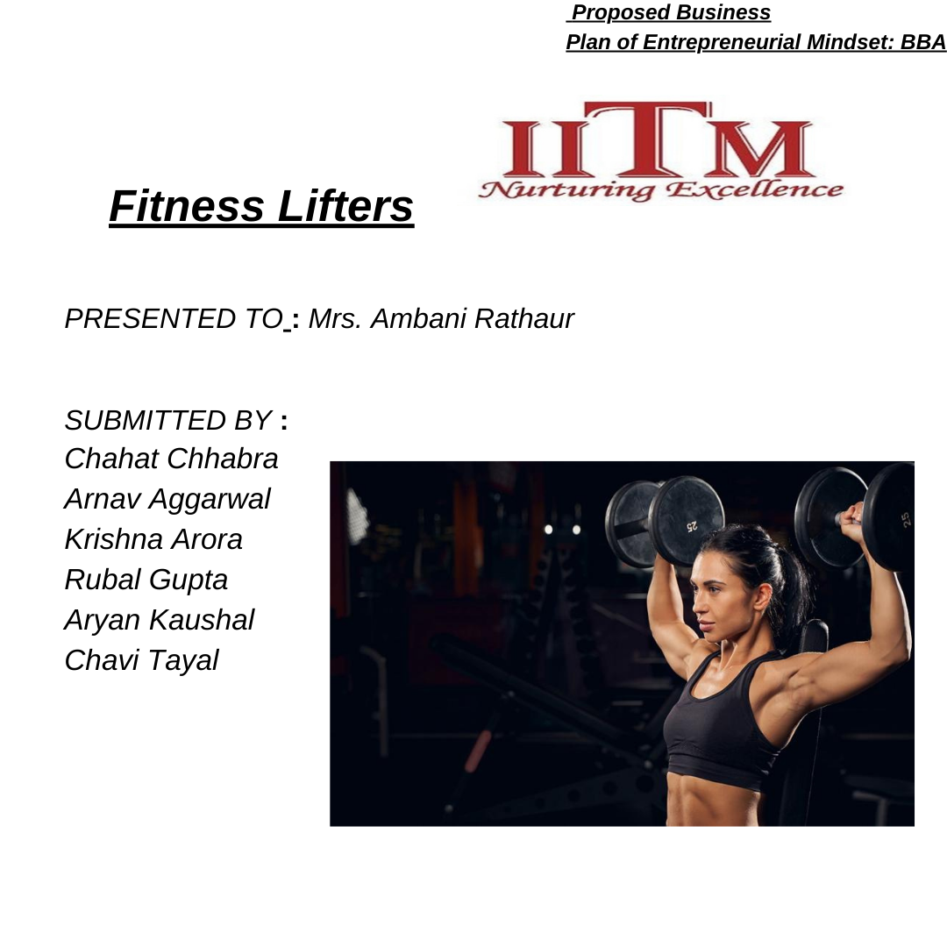

## GENERAL INTRODUCTION

NAME OF THE BUSINESS: FL Pvt Ltd - (Fitness Lifters Private Limited)

LOCATION OF BUSINESS: Sector – 139, Golf Course Rd., Gurugram

THE PRODUCT: Fitness Lifters provide Strength Training

equipments, Cardio equipments, and Functional equipments.

THE LEADERSHIP: This is a Start-up partnership firm which will be leaded by the six students of IITM (INSTITUTE OF

INFORMATION TECHNOLOGY AND MANAGEMENT)

THE INDUSTRY: The global fitness equipment market was valued at over USD11 billion in 2020 and was expected to

grow at CAGR of around 3% from 2021 to 2027.

THE FINANCIAL STATUS: The business will be started with an initial investment of Rs.30L (5L each by every

member).

ADVERTISEMENT MODEL:

* ONLINE PRESENCE
* PARTNERSHIPS AND COLLABORATION
* LOCALN EVENTS AND DEMONSTRATIONS ETC.

MISSION: Our mission is to empower individuals and businesses to prioritize health and well-being through the importation and distribution of cutting-edge fitness

equipment.

VISION: Our vision is to be a leading provider of high-quality fitness equipment, inspiring individuals, and the community to adopt healthier lifestyles and achieve their wellness goals. We envision a world where everyone has access to state-of-

the-art fitness solutions, promoting physical well-being and overall vitality

## ABOUT THE VENTURE

##### Fitness Lifters would be created in the form of a private company with six members leading the company and a bunch of skilled employes will be hired for growth and expansion of the business in the future. This business will be set up in Gurugram and the primary source of revenue will be generated from selling the best quality imported gym equipments. The main suppliers will be Titan Fitness (USA) and Horizon Fitness (Taiwan).

The scale of operations for Fitness Lifters, as a gym

equipment import company in India, can be approached in stages, gradually expanding based on market

penetration, demand, and financial capabilities. Here's a potential scaling strategy:

##### Initial Stage: Establishment and Market Entry

* **Growth Phase: Expansion and Diversification**

##### Advanced Stage: Dominance and Innovation

By scaling operations strategically through these stages, Fitness Lifters can steadily grow its presence and impact within the Indian gym equipment import market while maintaining a focus on quality, innovation, and customer satisfaction.

## ORGANIZATIONAL PLAN

**The company will be having following departments and each of the departments will have 100-150 workers. The heads of the following department are as follows:**

CHAHAT CHHABRA

(Marketing Team Manager)

The manager will be responsible for developing, implementing, and executing marketing strategies for an entire organization.

ARNAV AGGARWAL

(Sales Team Manager)

The manager will be responsible for sales growth and hitting sales targets successfully by managing the sales team. Designing and implementing a strategic sales plan that expands the company’s

customer base and ensures its strong presence.

KRISHNA ARORA

(Human Resource Manager)

The manager will be responsible for strategic planning for staffing, conducting interviews and hiring personnel to foster a productive atmosphere.

CHAVI TAYAL

(Research and Development Team Manager)

The manager will be responsible for analyzing trends, demand and target customer and reference market needs in collaboration with the marketing department to anticipate trends.

RUBAL GUPTA

(Quality Assurance and Management Team Manager)

The manager will be responsible for overseeing the activities of the quality assurance department and staff, developing, implementing, and maintaining a system of quality and reliability testing for the fitness equipments to ensure their quality and better functioning.

ARYAN KAUSHAL

(Finance Manager)

The manager will be responsible for budgeting and forecasting.

Leading the analysis of monthly and quarterly numbers and

presenting findings to the board. Managing an end-to-end audit process of current systems – while acting as the first point of contact for external auditors.TYPES OF TECHNOLOGY TO BE USED

Company requires the following equipment and service provider expenses:

|  |  |
| --- | --- |
| **INVENTORY** | **EXPENSE** |
| Three computer workstations with the following equipments:   * Three Microsoft licensing * Broadband Internet Connection * Two Laser Printers * Peachtree Accounting | Rs.90,000 |

|  |  |
| --- | --- |
|  |  |
| Fax Machine | Rs.5,000 |
| Copier | Rs.2,000 |
| Three Sets of Office Furniture | Rs.30,000 |
| Large desk and chairs for  meeting room | Rs.13,000 |
| Mobile Phone | Rs.2,000 |
| Attorney fees for contract generation and partnership  formation | Rs. 40,000 |

|  |  |
| --- | --- |
| Accountant fees for accounting  system set up | Rs. 45,000 |
| Website development set up fees | Rs.15,000 |
| Brochure creation and printing | Rs. 5000 |
| Two-line phone system | Rs. 3000 |

PRODUCT LIST STRENGTH TRAINING EQUIPMENTS:

1. **Barbells and Weight Plates**: These are fundamental to

strength training. Barbells come in various lengths and weights, while weight plates are available in different sizes (e.g., 2.5 lbs, 5 lbs, 10 lbs, etc.).

1. **Dumbbells**: These are versatile and come in various shapes and sizes, including adjustable and fixed-weight varieties.
2. **Weight Benches**: A weight bench is essential for various

exercises such as bench presses, dumbbell presses, and seated exercises. Flat, adjustable, and incline benches are popular options.

**Power Racks and Squat Racks**: These are critical for safety during heavy lifts like squats and bench presses.

CARDIO EQUIPMENTS:

1. **TRADEMILLS:** Probably the most popular cardio machine, treadmills simulate walking or running. They come in various

sizes and capabilities, including manual and motorized versions, with features like incline settings, heart rate monitors, and pre- programmed workouts.

1. **Elliptical Trainers:** These machines simulate walking, running, or climbing stairs without causing excessive pressure on the joints. They provide a full-body workout and have adjustable

resistance levels.

1. **Stationary Bikes:** There are two main types: upright bikes and recumbent bikes. Upright bikes simulate regular bicycles, while

recumbent bikes have a more reclined seating position. Both offer cardiovascular benefits and various resistance settings.

1. **Rowing Machines:** These simulate rowing a boat and engage multiple muscle groups. They provide a low- impact, high-calorie-burning workout.

#### FUNCTIONAL TRAINING EQUIPMENTS:

**Kettlebells:** These are cast-iron weights with a handle. They come in various weights and are used for exercises like swings, squats, Turkish get-ups, and more. Look for durable materials and ergonomic designs.

**Resistance Bands:** Elastic bands of different resistance levels are excellent for adding intensity to workouts. They come in various types such as loop bands, tube bands, and therapy bands.

**Suspension Trainers:** Systems like TRX use straps and handles to leverage body weight for resistance training. They are

versatile and can be used for a wide range of exercises targeting different muscle groups.

## MARKETING POLICY

#### PRODUCT:

1. **BARBELLS AND WEIGHT PLATES**
2. **DUMBBELLS**
3. **WEIGHT BENCHES**
4. **POWER RACKS AND SQUACT RACKS**
5. **TRADEMILLS**
6. **ELLIPTICAL TRAINERS**
7. **STATIONARY BIKES**
8. **ROWING MACHINES**
9. **KETTLE BIKES**
10. **RESISTANCE BANDS**
11. **SUSPENSION TRAINERS**

PRICING POLICY:

* 1. **Revenue Streams:**
     + **Product Sales:** Revenue generated from the sale of gym equipment.
     + **Service Income:** Additional income from installation, maintenance, and repair services.

### Cost Structure:

* + - **Product Procurement:** Costs associated with importing goods, including manufacturing, shipping, and customs duties.
    - **Operational Expenses:** Warehouse rent, employee salaries, marketing expenses, and overhead costs.

### Financial Projections:

* + - **Develop a comprehensive financial forecast covering sales projections, expenses, and profitability over the next 3-5 years.**

## PROMOTION:

##### Online Presence:

**Website:** Creating a professional, user-friendly website that showcases fitness lifters, their benefits, and purchasing options.

**Social Media:** Using platforms like Instagram, Facebook, and Twitter to share workout tips, success stories, product demos, and special offers.

**Content Marketing:** Starting a blog or YouTube channel offering fitness advice, tutorials, and highlighting your fitness equipment.

**Email Marketing:** Building an email list to send newsletters with updates, promotions, and relevant fitness content.

##### Partnerships and Collaborations:

Collaborating with fitness influencers, gyms, or trainers for endorsements, reviews, or joint promotions.

Partnerships with related businesses like nutrition stores or wellness centres for cross-promotion.

##### Local Events and Demonstrations:

Hosting fitness events, workshops, or demos at local gyms, community centres, or health fairs to showcase your equipment.

Offering free trials or demonstrations to allow potential customers to experience the equipment firsthand.

##### Referral Programs and Customer Incentives:

Creating a referral program where existing customers get discounts or rewards for referring others.

Offering exclusive discounts, freebies, or loyalty programs to incentivize repeat purchases.

##### SEO and Online Advertising:

Optimizing your website for search engines to increase visibility.

Utilizing paid advertising on Google Ads or social media platforms to target potential customers based on their interests and demographics.

TYPE OF CUTOMERS:

Fitness Lifters Importing has identified three distinct customer segments that will be targeted for sale of the fitness equipment:

##### Distributors

* + - **Fitness Clubs**
    - **Vertical Markets**

#### NATURE OF CUSTOMERS:

* + - **Quality Seekers:** Customers who prioritize durability, performance, and quality assurance in gym equipment.
    - **Price-Conscious Buyers:** Customers looking for competitive pricing without compromising on quality.
    - **Innovators and Trend Followers:** Those interested in cutting-edge equipment aligning with the latest fitness trends and technology.
    - **Long-term Partnerships:** Gyms and commercial

establishments seeking reliable suppliers for ongoing equipment needs and upgrades.

* + - **Service-Oriented Clients:** Businesses valuing additional services like installation, maintenance, and after-sales support.

#### CHHANELS OF DISTRIBUTION:

* + - **Direct Sales:** Establish direct relationships with gyms, fitness centers, and wholesalers through sales

representatives.

* + - **Online Sales:** Offer online purchasing options with nationwide delivery and robust customer support.

## HUMAN RESOURCE PLAN

Fitness Lifters requires the following skilled personnel:

1. Assistant Sales Team Manager
2. Assistant Marketing Team Manager
3. Accountants
4. Media Department

PROCEDURE FOR RECRUITMENT:

EXPECTED RECRUITMENT PERIOD: 2 Months TOTAL NO. OF JOB POSITIONS AVAILABLE: 22 **RECRUITMENT PROCESS:**

##### Application via LinkedIn and mails.

1. **Interview Process**

##### Skills Assessment

1. **Reference Checks and Background Verification**

##### Offer and Onboarding

1. **Training and Development**

##### Performance Management

1. **Legal Compliance**
2. **Acceptability and Feedback Loop**

## MARKET RESEARCH

The fitness equipment industry encompasses a wide range of products and services related to physical fitness and exercise. It includes manufacturing, distribution, sales, and servicing of

various equipment used for fitness and workout purposes. Here are some key insights into the fitness equipment industry:

##### Market Size and Growth:

* **Global Market:** The global fitness equipment market size was valued at billions of dollars and has been steadily

growing due to increased health awareness, fitness.

**Regional Markets:** Different regions show varying growth rates influenced by factors such as economic development, lifestyle changes, and health consciousness.

The global fitness equipment market was valued at over USD11 billion in 2020 and was expected to grow at CAGR of around 3% from 2021 to 2027.The global fitness equipment market has experienced steady growth, with regions like North America, Europe, and Asia-Pacific leading in terms of market size and demand.

##### Competitive Landscape:

Established players and new entrants compete through innovation, quality, pricing, and customer service, driving

continuous advancements in equipment design and features.

## FINANCIAL PLAN

CAPITAL REQUIREMENTS:

The business model is expected to require an annual capital requirement of Rs 25 LAKH. With an initial investment of Rs 30 LAKH which also involves contingency fund of Rs 5 LAKH to meet uncertainties and any loss in case. This investment would operate the business for two additional financial year. For the further investment requirements company may take loans through bank, government and can all issue shares and debentures.

|  |  |  |
| --- | --- | --- |
|  | VALUE | PERCENTAGES |
| Inventory | Rs.1,50,000 | 5% |
| Logistics and Import Costs (including gym  equipments) | Rs.20,00,000 | 67% |
| Operational Expenses | Rs.2,50,000 | 9% |
| Accounting system fees | Rs.45,000 | 2% |
| Attorney Fees | Rs.40,000 | 1% |
| Website development set  up fees | Rs.15,000 | 1% |
| Contingency fund | Rs.5,00,000 | 15% |
| Total | Rs.30,00,000 | 100% |

#### FINANCIAL OUTLOOK:

This business model is expected to generate a return of 40% after cost incurred on it in first year while the business is being capable of generating more income and expansion in next 2 years and is expected to rise 40% to 70%.

# WHAT MAKES

FITNESS LIFTERS UNIQUE?

## All other strength fitness equipment has users placed in a seated position

when performing the exercises. Fitness Lifters, instead, has the user stand. This is advantageous for several reasons.

## First, this strengthens lower body muscles that hold the body upright. It also strengthens central motor skills needed to maintain an upright position relative to the offsetting forces

generated from the weight lifting.

# SUMMARY

Fitness Lifters, a cutting-edge fitness equipment startup, aims to revolutionize the industry through innovation, quality, and customer-centric design. Our business plan focuses on leveraging market insights, technology, and strategic partnerships to address evolving fitness needs.

With a keen eye on sustainability and user experience, Fitness Lifters plans to fill market gaps by delivering high- quality, eco-friendly fitness equipment. Our scalable business model and diversified revenue streams ensure both profitability and growth.

Backed by a passionate team dedicated to excellence, Fitness Lifters is poised to disrupt the fitness equipment landscape.

We invite investors and partners to join us in creating a brand synonymous with innovation and reliability in the fitness industry.

In conclusion, Fitness Lifters is not just a company; it’s a commitment to transforming the fitness experience globally. We're excited to embark on this journey and invite stakeholders to be part of our vision for a healthier, fitter world.".

# REFRENCES